

USEFUL JAPANESE DICTIONARY FOR VIETNAMESE

DETAIL DESIGN DOCUMENT

Data Design

**Project Code: UJD_VN**

**Document Code: UJD_VN_Data Design_v1.0_EN**

**Ha Noi, 26/06/2014**

Record of change

*A - Added M - Modified D – Deleted

|  |  |  |  |  |
| --- | --- | --- | --- | --- |
| Effective Date | Changed Items | A* M, D | Change Description | New Version |
| 26/06/2014 | Add new | A |  | V1.0 |
| 07/07/2014 | Modified | M | ERD, table diagram | V1.1 |
| 05/08/2014 | Modified | M |  | V1.2 |
| 11/08/2014 | Modified | M | Table database | V1.3 |
|  |  |  |  |  |
|  |  |  |  |  |
|  |  |  |  |  |
|  |  |  |  |  |
|  |  |  |  |  |
|  |  |  |  |  |

SIGNATURE PAGE

**ORIGINATOR:** Pham Tien Dat 26/06/2014

Developer

**REVIEWERS:**

**APPROVAL:** Nguyen Van Sang

Supervisor

TABLE OF CONTENTS

1 Introduction 6

1.1 Purpose 6

1.2 Definitions, Acronyms and Abbreviations 6

1.3 References 6

1.4 Overview 6

2 Database 7

2.1 ERDs 7

2.2 Table Database 11

2.2.1 Table diagram 11

2.2.2 User table 13

2.2.3 Vocabulary table 14

2.2.4 Meaning table 15

2.2.5 Sentence table 16

2.2.6 VocabularySentence table 16

2.2.7 Grammar table 17

2.2.8 GrammarSentence table 18

2.2.9 Video table 18

2.2.10 Kanji table 19

2.2.11 Conversation table 19

2.2.12 ConversationContent table 20

2.2.13 Contact table 21

2.2.14 TrainingListening table 21

2.2.15 Sourcefile table 22

2.2.16 ReadingDocumnet table 22

2.2.17 ReadingVocabulary table 23

2.2.18 Test table 23

2.2.19 Question table 24

2.2.20 ReadingArtile table 24

2.2.21 TrackingMark table 25

2.2.22 Answer table 25

3 File design 27

4 Code Design 28

4.1 Customer Code 28

5 Other considerations 29

6 Appendix 30

6.1 Data format symbol 30

# Introduction

## Purpose

Useful Japanese Dictionary for Vietnamese data design document describes structure of database and file structure of system including internal file structure as well as interface file structure.

## Definitions, Acronyms and Abbreviations

|  |  |  |
| --- | --- | --- |
| Abbreviations | Description | Comment |
| PK/FK | Primary/ Foreign key | Use to indicate that a field is a primary or foreign key in table |
| V | Check value null | Set value “null” for attribute in table |
| Y | Check value unique | Set value “unique” for attribute in table |

## References

List the entire reference document such as: other document of the system, or the technical article.

|  |  |
| --- | --- |
| Document Number | Title |
| UJD_VN_ Class design_v1.1_EN | N/A |
| UJD_VN_ Screen design_v1.0_EN | N/A |

## Overview

General overview of the detail design such as what is the structure of the document: N/A

# Database

## ERDs

Entity relationship diagrams

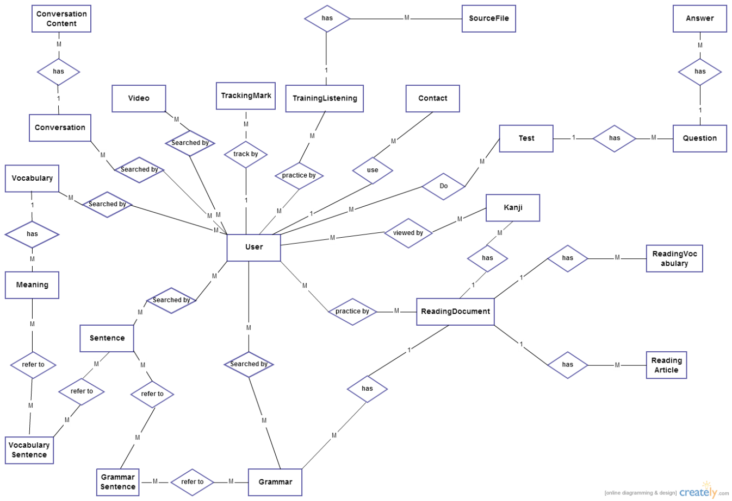

**Figure 1: Entity relationship diagrams**

|  |  |  |
| --- | --- | --- |
| **No** | **Entity** | **Description** |
| 1 | User | User is all of people using website include guest and member who registered. |
| 2 | Vocabulary | Vocabulary is all of new word in Japanese. |
| 3 | Meaning | Meaning of vocabulary. |
| 4 | VocabularySentence | VocabularySentence include reference between Meaning and Sentence. |
| 5 | Sentence | Sentence is example of vocabulary and grammar. |
| 6 | Grammar | Grammar is structure sentences in Japanese. |
| 7 | Video | Video include title and link of video. |
| 8 | GrammarSentence | GrammarSentence include reference between Grammar and Sentence. |
| 9 | Kanji | Kanji is all of kanji in Japanese. |
| 10 | Conversation | Conversation in all lesson. |
| 11 | ConversationContent | Content of conversation. |
| 12 | Contact | Contact is Q&A, opinion of member send to admin. |
| 13 | TrainingListening | All listening lesson in Japanese. |
| 14 | SourceFile | Source of file listening. |
| 15 | ReadingDocument | Document that user can read on website. |
| 16 | ReadingVocabulary | Reference to ReadingDocument. |
| 17 | ReadingArticle | Reference to ReadingDocument. |
| 18 | TrackingMark | User can check mark of test that they did it. |
| 19 | Test | Test is some quiz that member can do it. |
| 20 | Question | Reference to Test. |
| 21 | Answer | Reference to Test. |

List of relations of entities and brief description

|  |  |  |  |  |
| --- | --- | --- | --- | --- |
| **No** | **Entity A** | **Entity B** | **Relation** | **Description** |
| 1 | User | Vocabulary | Many to many | Each User can search many words and each word is searched by many users |
| 2 | User | Sentence | Many to many | Each User can search many sentences and each sentence is searched by many users |
| 3 | User | Grammar | Many to many | Each User can search many grammars and each grammar is searched by many users |
| 4 | User | Video | Many to many | Each User can search many videos and each video is searched by many users |
| 5 | User | Kanji | Many to many | Each User can search many Kanji and each Kanji is searched by many users |
| 6 | User | Conversation | Many to many | Each User can search many conversation and each conversation is searched by many users |
| 7 | User | Contact | One to many | Each user can send many contacts. |
| 8 | User | TrainingListening | Many to many | Each User can train many listen and each listen is trained by many users |
| 9 | User | ReadingDocument | Many to many | Each User can read many documents and each document is read by many users |
| 10 | User | TrackingMark | One to many | Each User can track mark of many tests |
| 11 | User | Test | Many to many | Each User can do many tests and each test is did by many users |
| 12 | Vocabulary | Meaning | One to many | Each Vocabulary has many meanings. |
| 13 | Conversation | ConversationContent | One to many | Each Conversation has many conversation content. |
| 14 | TrainingListening | SourceFile | One to many | Each TrainingListening has many source file. |
| 15 | Test | Question | One to many | Each Test has many questions |
| 16 | Question | Answer | One to many | Each Question has many answers |
| 17 | ReadingDocument | Kanji | One to many | Each ReadingDocument has many kanji |
| 18 | ReadingDocument | Grammar | One to many | Each ReadingDocument has many grammars |
| 19 | ReadingDoccument | ReadingVocabulary | One to many | Each ReadingDocumnet has many reading vocabulary |
| 20 | ReadingDocument | ReadingArticle | One to many | Each ReadingDocument has many reading article |
| 21 | Grammar | Sentence | Many to many | Each Grammar has many sentence and each sentence has many grammar. |
| 22 | Vocabulary | Sentence | Many to many | Each Vocabulary has many sentence and each sentence has many vocabulary. |

## Table Database

### Table diagram

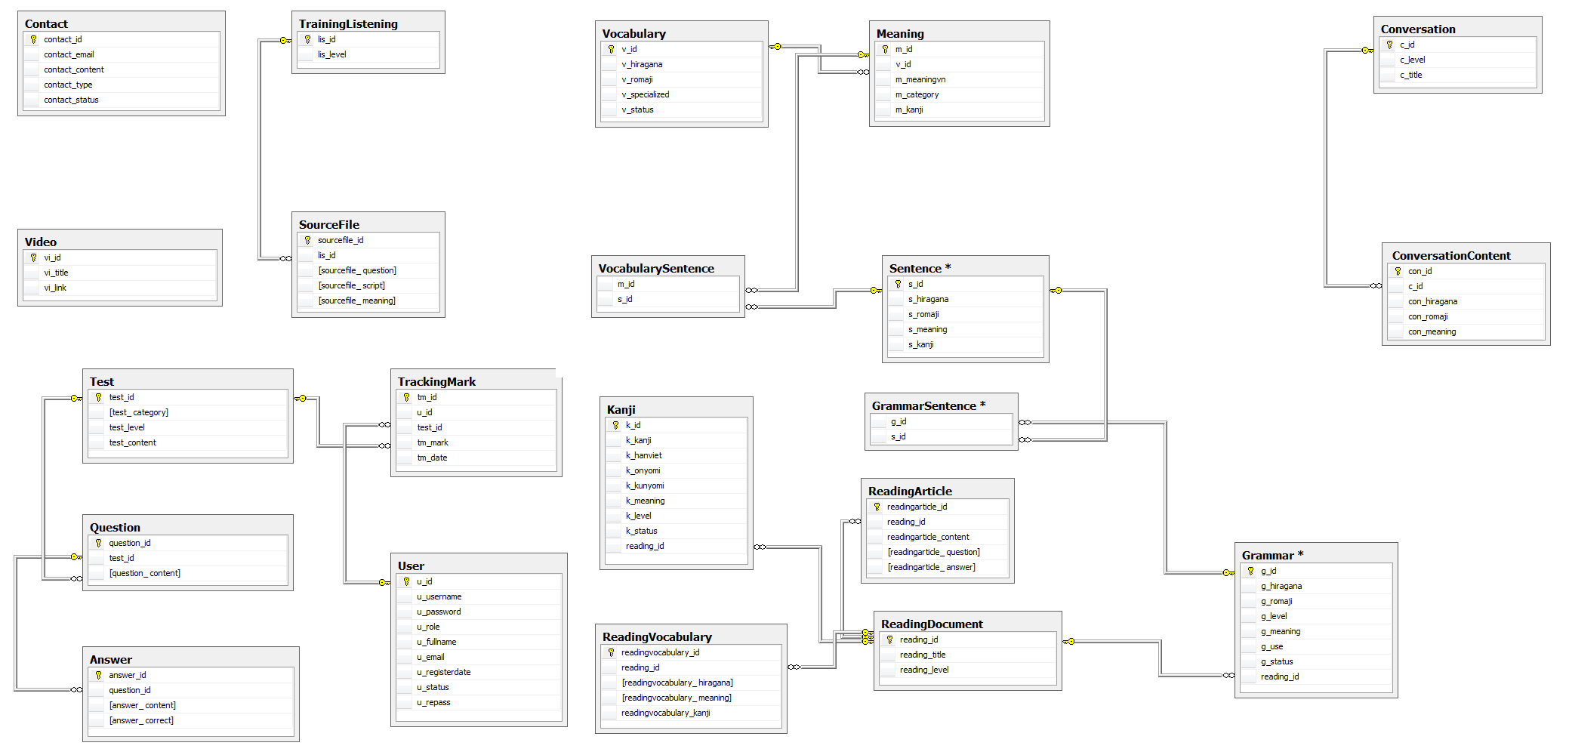 Figure 2: Table diagram

n

List of tables and brief description

|  |  |  |
| --- | --- | --- |
| No | Table Name | Description |
|  | User | Store all user information. |
|  | Vocabulary | Store some information of vocabulary. |
|  | Meaning | Store some information of vocabulary. |
|  | Sentence | Store all information of sentence. |
|  | VocabularySentence | Store id of Vocabulary and Sentence. |
|  | Grammar | Store all information of grammar. |
|  | GrammarSentence | Store id of Grammar and Sentence. |
|  | Video | Store all information of video. |
|  | Kanji | Store all information of kanji. |
|  | Conversation | Store information of conversation. |
|  | ConversationContent | Store information of conversation. |
|  | Contact | Store all content of contact that member send to admin. |
|  | TrainingListening | Store information of listening. |
|  | Sourcefile | Store information of listening. |
|  | ReadingDocument | Store information of document. |
|  | ReadingVocabulary | Store all information of vocabulary in document. |
|  | Test | Store information of test. |
|  | Question | Store content of question of test. |
|  | ReadingArticle | Store all information of article. |
|  | TrackingMark | Store all information of user who did test. |
|  | Answer | Store answer of question. |

### User table

|  |  |  |  |  |  |  |  |  |  |
| --- | --- | --- | --- | --- | --- | --- | --- | --- | --- |
| No | Field Name | Type | Length | Size | Null | Unique | P/F Key | Default | Description |
|  | u_id | Int |  |  |  |  | P |  | PRIMARY KEY  This is automatically increase value 1 |
|  | u_username | Varchar | 32 |  |  | Y |  |  | Username login |
|  | u_password | Varchar | 32 |  |  |  |  |  | Store password login of user.  Using md5 algorithm. |
|  | u_role | int |  |  |  |  |  |  | Admin can assign permission for user |
|  | u_fullname | Varchar | 100 |  |  |  |  |  | User’s name display |
|  | u_email | Varchar | 100 |  |  | Y |  |  | User’s email |
|  | u_registerdate | Date |  |  |  |  |  |  | Date register |
|  | u_status | Int |  |  |  |  |  |  | Active or deactive |

### Vocabulary table

|  |  |  |  |  |  |  |  |  |  |
| --- | --- | --- | --- | --- | --- | --- | --- | --- | --- |
| No | Field Name | Type | Length | Size | Null | Unique | P/F Key | Default | Description |
|  | v_id | Int |  |  |  |  | P |  | PRIMARY KEY  This is automatically increase value 1 |
|  | v_hiragana | varchar | 200 |  |  |  |  |  | Vocabulary’s hiragana |
|  | v_romaji | Varchar | 200 |  |  |  |  |  | Vocabulary’s romaji |
|  | v_status | int |  |  |  |  |  |  | Vocabulary’s status |

### Meaning table

|  |  |  |  |  |  |  |  |  |  |
| --- | --- | --- | --- | --- | --- | --- | --- | --- | --- |
| No | Field Name | Type | Length | Size | Null | Unique | P/F Key | Default | Description |
|  | m_id | Int |  |  |  |  | P |  | PRIMARY KEY  This is automatically increase value 1 |
|  | v_id | Int |  |  |  |  | FK |  | Foreign key to Vocabulary |
|  | m_meaningvn | varchar | 500 |  |  |  |  |  | Meaning of vocabulary |
|  | m_category | Varchar | 10 |  |  |  |  |  | Category of vocabulary |
|  | m_kanji | Varchar | 10 |  | Y |  |  |  | Kanji of vocabulary |
|  | m_specialized | varchar | 200 |  |  |  |  |  | Vocabulary’s specialized |

### Sentence table

|  |  |  |  |  |  |  |  |  |  |
| --- | --- | --- | --- | --- | --- | --- | --- | --- | --- |
| No | Field Name | Type | Length | Size | Null | Unique | P/F Key | Default | Description |
|  | s_id | Int |  |  |  |  | P |  | PRIMARY KEY  This is automatically increase value 1 |
|  | s_hiragana | varchar | 1000 |  |  |  |  |  | Sentence’s hiragana |
|  | s_romaji | Varchar | 1000 |  |  |  |  |  | Sentence’s romaji |
|  | s_meaning | varchar | 1000 |  |  |  |  |  | Sentence’s meaning |
|  | s_kanji | varchar | 1000 |  |  |  |  |  | Sentence’s kanji |

### VocabularySentence table

|  |  |  |  |  |  |  |  |  |  |
| --- | --- | --- | --- | --- | --- | --- | --- | --- | --- |
| No | Field Name | Type | Length | Size | Null | Unique | P/F Key | Default | Description |
|  | m_id | Int |  |  |  |  | FK |  | Foreign key to Meaning |
|  | s_id | Int |  |  |  |  | FK |  | Foreign key to Sentence |

### Grammar table

|  |  |  |  |  |  |  |  |  |  |
| --- | --- | --- | --- | --- | --- | --- | --- | --- | --- |
| No | Field Name | Type | Length | Size | Null | Unique | P/F Key | Default | Description |
|  | g_id | Int |  |  |  |  | P |  | PRIMARY KEY  This is automatically increase value 1 |
|  | g_hiragana | varchar | 200 |  |  |  |  |  | Grammar’s hiragana |
|  | g_romaji | Varchar | 200 |  |  |  |  |  | Grammar’s romaji |
|  | g_level | Varchar | 10 |  |  |  |  |  | Grammar’s level |
|  | g_meaning | varchar | 200 |  |  |  |  |  | Grammar’s meaning |
|  | g_use | varchar | 1000 |  |  |  |  |  | Grammar’s use |
|  | g_status | int |  |  |  |  |  |  | Grammar’s status |
|  | reading_id | Varchar | 20 |  |  |  | FK |  | Foreign key to ReadingDocument |

### GrammarSentence table

|  |  |  |  |  |  |  |  |  |  |
| --- | --- | --- | --- | --- | --- | --- | --- | --- | --- |
| No | Field Name | Type | Length | Size | Null | Unique | P/F Key | Default | Description |
|  | m_id | Int |  |  |  |  | FK |  | Foreign key to Meaning |
|  | s_id | Int |  |  |  |  | FK |  | Foreign key to Sentence |

### Video table

|  |  |  |  |  |  |  |  |  |  |
| --- | --- | --- | --- | --- | --- | --- | --- | --- | --- |
| No | Field Name | Type | Length | Size | Null | Unique | P/F Key | Default | Description |
|  | vi_id | Int |  |  |  |  | P |  | PRIMARY KEY  This is automatically increase value 1 |
|  | vi_title | varchar | 200 |  |  |  |  |  | Video’s title |
|  | vi_link | varchar | 200 |  |  |  |  |  | Video’s link |

### Kanji table

|  |  |  |  |  |  |  |  |  |  |
| --- | --- | --- | --- | --- | --- | --- | --- | --- | --- |
| No | Field Name | Type | Length | Size | Null | Unique | P/F Key | Default | Description |
|  | k_id | Int |  |  |  |  | P |  | PRIMARY KEY  This is automatically increase value 1 |
|  | k_kanji | varchar | 10 |  |  |  |  |  | Kanji in Japanese |
|  | k_hanviet | varchar | 50 |  |  |  |  |  | Kanji’s Vietnamese-Han |
|  | k_onyomi | varchar | 100 |  |  |  |  |  | Kanji’s onyomi |
|  | k_kunyomi | varchar | 100 |  |  |  |  |  | Kanji’s kunyomi |
|  | k_meaning | varchar | 200 |  |  |  |  |  | Kanji’s meaning |
|  | k_level | varchar | 10 |  |  |  |  |  | Kanji’s level |
|  | k_status | int |  |  |  |  |  |  | Kanji’s status |
|  | k_lesson | varchar | 20 |  |  |  |  |  | Kanji’s readingdocument |

### Conversation table

|  |  |  |  |  |  |  |  |  |  |
| --- | --- | --- | --- | --- | --- | --- | --- | --- | --- |
| No | Field Name | Type | Length | Size | Null | Unique | P/F Key | Default | Description |
|  | c_id | int |  |  |  |  | P |  | PRIMARY KEY  This is automatically increase value 1 |
|  | c_level | varchar | 10 |  |  |  |  |  | Conversation’s level |
|  | c_title | varchar | 100 |  |  |  |  |  | Conversation’s title |
| 1. C_ | c_image | Varchar | 200 |  |  |  |  |  | Conversation’s image |

### ConversationContent table

|  |  |  |  |  |  |  |  |  |  |
| --- | --- | --- | --- | --- | --- | --- | --- | --- | --- |
| No | Field Name | Type | Length | Size | Null | Unique | P/F Key | Default | Description |
|  | con_id | Int |  |  |  |  | P |  | PRIMARY KEY  This is automatically increase value 1 |
|  | c_id | int |  |  |  |  | FK |  | Foreign key to Sentence |
|  | con_title | Varchar | 200 |  |  |  |  |  | Content’s title |
|  | con_hiragana | varchar | 5000 |  |  |  |  |  | Conversation’s hiragana |
|  | con_romaji | Varchar | 5000 |  |  |  |  |  | Conversation’s romaji |
|  | con_meaning | varchar | 5000 |  |  |  |  |  | Conversation’s meaning |
| 1. c | con_file | Varchar | 200 |  |  |  |  |  | File listen of conversation |

### Contact table

|  |  |  |  |  |  |  |  |  |  |
| --- | --- | --- | --- | --- | --- | --- | --- | --- | --- |
| No | Field Name | Type | Length | Size | Null | Unique | P/F Key | Default | Description |
|  | contact_id | Int |  |  |  |  | P |  | PRIMARY KEY  This is automatically increase value 1 |
|  | contact_email | varchar | 100 |  |  |  |  |  | Contact’s email |
|  | contact_content | varchar | 5000 |  |  |  |  |  | Contact’s content |
|  | contact_type | Varchar | 10 |  |  |  |  |  | Contact’s type |
|  | contact_status | int |  |  |  |  |  |  | Contact’s status |

### TrainingListening table

|  |  |  |  |  |  |  |  |  |  |
| --- | --- | --- | --- | --- | --- | --- | --- | --- | --- |
| No | Field Name | Type | Length | Size | Null | Unique | P/F Key | Default | Description |
|  | lis_id | int |  |  |  |  | P |  | PRIMARY KEY  This is automatically increase value 1 |
|  | lis_title | Varchar | 500 |  |  |  |  |  | Listening’s title |
|  | lis_level | varchar | 10 |  |  |  |  |  | Listening’s level |

### Sourcefile table

|  |  |  |  |  |  |  |  |  |  |
| --- | --- | --- | --- | --- | --- | --- | --- | --- | --- |
| No | Field Name | Type | Length | Size | Null | Unique | P/F Key | Default | Description |
|  | sourcefile_id | int |  |  |  |  | P |  | PRIMARY KEY  This is automatically increase value 1 |
|  | lis_id | Int |  |  |  |  | FK |  | Foreign key to TrainingListening |
|  | sourcefile_file | Varchar | 100 |  |  |  |  |  | Listen’s file |
|  | sourcefile_ question | varchar | 5000 |  |  |  |  |  | Listen’s question |
|  | sourcefile_ script | varchar | 5000 |  |  |  |  |  | Listen’s script |
|  | sourcefile_ meaning | varchar | 5000 |  |  |  |  |  | Listen’s meaning |
|  | sourcefile_ answer | Varchar | 100 |  |  |  |  |  | Listen’s answer |

### ReadingDocumnet table

|  |  |  |  |  |  |  |  |  |  |
| --- | --- | --- | --- | --- | --- | --- | --- | --- | --- |
| No | Field Name | Type | Length | Size | Null | Unique | P/F Key | Default | Description |
|  | reading_id | int |  |  |  |  | P |  | PRIMARY KEY  This is automatically increase value 1 |
|  | reading_code | varchar | 50 |  |  |  |  |  | Reading’s code |
|  | reading_title | varchar | 100 |  |  |  |  |  | Reading’s title |
|  | reading_level | varchar | 10 |  |  |  |  |  | Reading’s level |

### ReadingVocabulary table

|  |  |  |  |  |  |  |  |  |  |
| --- | --- | --- | --- | --- | --- | --- | --- | --- | --- |
| No | Field Name | Type | Length | Size | Null | Unique | P/F Key | Default | Description |
|  | readingvocabulary_id | Int |  |  |  |  | P |  | PRIMARY KEY  This is automatically increase value 1 |
|  | reading_id | int |  |  |  |  | FK |  | Foreign key to ReadingDocument |
|  | readingvocabulary_ hiragana | varchar | 100 |  |  |  |  |  | Vocabulary’s hiragana |
|  | readingvocabulary_ meaning | varchar | 100 |  |  |  |  |  | Vocabulary’s meaning |
|  | readingvocabulary_kanji | varchar | 10 |  |  |  |  |  | Vocabulary’s kanji |
|  | readingvocabulary_type | Varchar | 50 |  |  |  |  |  | Type of readingvocabulary |

### Test table

|  |  |  |  |  |  |  |  |  |  |
| --- | --- | --- | --- | --- | --- | --- | --- | --- | --- |
| No | Field Name | Type | Length | Size | Null | Unique | P/F Key | Default | Description |
|  | test_id | int |  |  |  |  | P |  | PRIMARY KEY  This is automatically increase value 1 |
|  | test_title | varchar | 20 |  |  |  |  |  | Test’s title |
|  | test_ category | varchar | 50 |  |  |  |  |  | Test’s category |
|  | test_level | Varchar | 10 |  |  |  |  |  | Test’s level |
|  | test_content | varchar | 5000 |  |  |  |  |  | Test’s content |

### Question table

|  |  |  |  |  |  |  |  |  |  |
| --- | --- | --- | --- | --- | --- | --- | --- | --- | --- |
| No | Field Name | Type | Length | Size | Null | Unique | P/F Key | Default | Description |
|  | question_id | Int |  |  |  |  | P |  | PRIMARY KEY  This is automatically increase value 1 |
|  | test_id | int |  |  |  |  | FK |  | Foreign key to Test |
|  | question_ content | varchar | 200 |  |  |  |  |  | Question’s content |

### ReadingArtile table

|  |  |  |  |  |  |  |  |  |  |
| --- | --- | --- | --- | --- | --- | --- | --- | --- | --- |
| No | Field Name | Type | Length | Size | Null | Unique | P/F Key | Default | Description |
|  | readingarticle_id | Int |  |  |  |  | P |  | PRIMARY KEY  This is automatically increase value 1 |
|  | reading_id | int |  |  |  |  |  |  | Foreign key to ReadingDocument |
|  | readingarticle_content | Varchar | 5000 |  |  |  |  |  | Article’s content |
|  | readingarticle_ question | Varchar | 5000 |  |  |  |  |  | Artcle’s question |
|  | readingarticle_ answer | Varchar | 5000 |  |  |  |  |  | Article’s answer |
|  | readingarticle_mening | Varhar | 5000 |  |  |  |  |  | Translate of article |

### TrackingMark table

|  |  |  |  |  |  |  |  |  |  |
| --- | --- | --- | --- | --- | --- | --- | --- | --- | --- |
| No | Field Name | Type | Length | Size | Null | Unique | P/F Key | Default | Description |
|  | tm_id | Int |  |  |  |  | P |  | PRIMARY KEY  This is automatically increase value 1 |
|  | u_id | Int |  |  |  |  | FK |  | Foreign key to User |
|  | test_id | int |  |  |  |  | FK |  | Foreign key to Test |
|  | tm_mark | varchar | 10 |  |  |  |  |  | Test’s mark |
|  | tm_date | Datetime |  |  |  |  |  |  | Test’s date |

### Answer table

|  |  |  |  |  |  |  |  |  |  |
| --- | --- | --- | --- | --- | --- | --- | --- | --- | --- |
| No | Field Name | Type | Length | Size | Null | Unique | P/F Key | Default | Description |
|  | answer_id | Int |  |  |  |  | P |  | PRIMARY KEY  This is automatically increase value 1 |
|  | question_id | Int |  |  |  |  | FK |  | Foreign key to Question |
|  | answer_ content | varchar | 200 |  |  |  |  |  | Answer’s content |
|  | answer_ correct | int |  |  |  |  |  |  | Answer’s correct |

# Appendix

## Data format symbol

Following symbols are used to describe format of data field in files as well as in tables.

|  |  |
| --- | --- |
| Symbol | Description |
| # | Digit placeholder. |
| . | Decimal placeholder. |
| , | Thousands separator. |
| : | Time separator. |
| / | Date separator. |
| \ | Treat the next character in the mask string as a literal. This allows you to include the '#', '&', 'A', and '?' characters in the mask. This character is treated as a literal for masking purposes. |
| > | Convert all the characters that follow to uppercase. |
| < | Convert all the characters that follow to lowercase. |
| A | Alphanumeric character placeholder (entry required). For example: a – z, A – Z, or 0 – 9. |
| A | Alphanumeric character placeholder (entry optional). |
| 9 | Digit placeholder (entry optional). For example: 0 – 9. |
| 0 | Digit placeholder (entry required). For example: 0 – 9. |
| C | Character or space placeholder (entry optional). Valid values for this placeholder are ANSI characters in the following ranges: 32-126 and 128-255. |
| & | Character placeholder (entry required). Valid values for this placeholder are ANSI characters in the following ranges: 32-126 and 128-255. |
| ? | Letter placeholder. For example: a – z or A – Z. |
| Literal | All other symbols are displayed as literals; that is, as themselves. bound in “” like “ABC” |